Annual Report for Alderton 2023
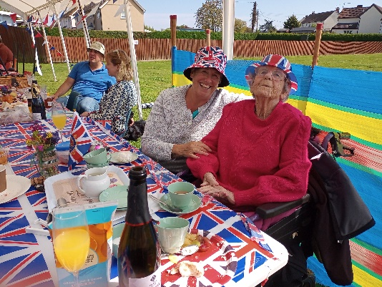
During 2023 there were various events held on the recreation ground (The Rec). The first was afternoon tea to celebrate the Coronation of King Charles III. Picture is 93-year-old Molly Fletcher and her daughter Diana Loughlin. Molly has lived in the village all her life.
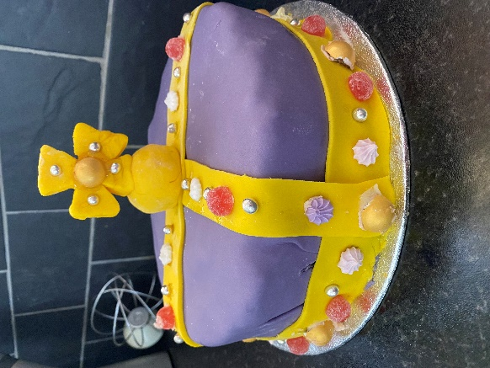
The village pub held a cake competition, pictured is the winning cake made by Carol Jaggers who works in the village shop.

The 2nd event was the Village Fete which was held on the recreation ground on Saturday 7th July. Sadly, I was unable to attend this event so I have no photographs.

The Parish Council met every 3 months and has a full council of 9 members. A new Chairman was elected in April, his name is Jeff Hayward and he has certainly been a new broom as much has happened in the 8 months, he has been chairman. This includes the external painting and general repair of The Pavilion on the recreation ground, also the sorting out of the grass cutting etc. This is now being carried out by local man John Mann and Jim Collins goes round with a strimmer tidying the edges. This change occurred due to Suffolk Norse who were cutting the grass etc becoming rather unreliable and leaving the grass for up to 3 months between cuts.

The village Bowls Club continues to be very successful. Two of our members won major county prizes, The Bowls Club has been operation since the mid 1940’s and has a well looked after ground. During this year, due to regulation changes and Safeguarding rules, the club needed to erect a changing room for visiting teams. This was a donated summer house which has been placed alongside the existing clubhouse.

Walking Football meets on the rec on the first Sunday of the month and has gone from strength to strength, now around 15 men meet each month to play.

Each Thursday, a group of people meet in the village hall for “Thirsty Thursday”. The drink tea and coffee and eat cake, chat is companionship is offered.

St Andrew’s Church has two services a month, both are communion, one at 8am and the 2nd at 9am. There have been no weddings, baptisms, or burials. The PCC met 3 times plus the APCM, at which all members of the Electoral Role have the right to attend. On Good Friday there was a “Walk of Witness” between Alderton and Bawdsey, 5 people walked carrying a wooden cross to witness Jesus’ walk to his crucifixion.

In November a coach trip to Ikea at Lakeside was organised with pick-up points at various villages including Alderton.

In December the Alderton Swan held its first Craft Fayre, at which local and not so local people could have a table for £10 to sell items they had made or grown. The event is due to be repeated 3 times in 2024. They also held a couple of Bingo nights and a fortnightly quiz. Every Thursday, they hold a pizza evening, people pre-order and pizzas are delivered from Woodbridge. Earlier in December the Parish Council and the Pub held a Santa’s Grotto and “switching on of the Christmas Tree lights” The Tree is erected on a piece of grass opposite the pub which also holds the village sign and a bench.

Judy Foulger
Village Recorder for Alderton
May 7th 2024

