Annual Report for Alderton 2020 & 2021
In January 2020 a meeting was held to discuss the fete planned for July, several people attended and plans were put in place for the Vintage Cars, a tea stall themed like a Lyons Tea Shop during WWII. 2020 was the 65th anniversary of the end of the war in Europe (VE Day), hence the idea of dressing up like “Nippies”.
With The Swan closed and up for sale, a quiz was held two or three times in the Village Hall, this was a “bring your own, food and drink” event with a nominal fee of £1 a head to enter.
In February the Rev Ruth Hatchett retired to great sadness from the villages for which she was vicar. An advert had been put up for a part-time priest to replace her covering the 7 villages. To date we still do not have a vicar.
Sadly, around Mothering Sunday, Boris Johnson told everyone to stay at home, therefore everything in the village stopped. The church closed its doors, the fete was cancelled as was the fledgling monthly quiz.
In April a new Team Rector was appointed to look after the 17 parishes that make up the Wilford Peninsula, he along with one other full-time priest would manage services and the need for a part-time vicar was deemed not necessary.
During the time that the church was closed some of the Elders started to produce a weekly reflection, this could include, prayers, some humour along with the readings for the week ahead. This was circulated via email to church people across all 7 villages. Along the same lines, the new Team Rector started offering services on Zoom, to start with these were well attended. He then moved to offering communion on-line and attendance dropped off.
In May, quite a few houses decorated with Union Jacks etc to celebrate the anniversary of VE Day. As we were in lockdown no celebrations could take place.
Judith & Bill Vaudry at Alderton Stores had a stable door installed and served everyone at the door, they also made deliveries to the most vulnerable in the village.
The Parish Council set up a scheme to collect prescriptions for anyone that asked, these were collected at the window of the closed village Doctors surgery, there were often long queues. This scheme has carried on and we are still collecting prescriptions if requested to do so.
As soon as the weather warmed up in July, and as restrictions were loosened, the Knit and natter group started to meet again, in the garden of the same private house that it moved to at the end of 2019. During the time of lockdown this had a maximum of 12 people attending. It was good to see people, share a cup of tea and a chat. We had to stop again when it got cold as it wasn’t possible to meet inside.
There was much controversy around the fate of The Alderton Swan, Pride of Suffolk were hoping to get a change of use and sell the building for development into a house, luckily the village managed to thwart that plan.
The PCC report that although there were no services there were several funerals, some held in the church and some outside.
The PCC held the Annual meeting in September 2021, this would by necessity need to cover both 2020 and 2021 as the last meeting was held in 2019. The electoral role holds steady at around 20.
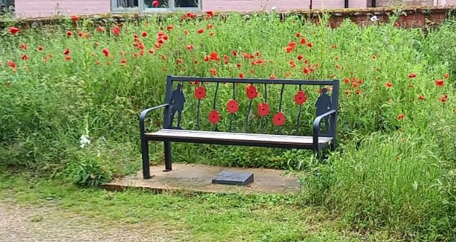
On November the 8th 2020, the Memorial Bench purchased with money raised by the Armistice 100 project was unveiled by Judith Vaudry for Alderton Shop. The bench now stands opposite the church door, often in the sun and is very popular as a place to sit and reflect. It commemorates all who served from the villages. The bench was made and delivered by Geoff Lock Ironworks from Sudbury. The poppies were painted red by local artist Miggie Wylie. The stone that can be seen under the bench was made by a local stonemason from Rendlesham and simply states “Remembering the brave men of Alderton, Bawdsey, Capell St Andrew, Hollesley, Ramsholt, Shottisham and Sutton who served in the Great War.” Local Builder Steve Collins and his brother laid the concrete base for no charge.
2021 saw more funerals in the church as there was limited opening for services, everyone had to socially distance and wear a mask.
The new Team Rector made major changes to service patterns and the 8am service held in St Andrew’s Alderton was stopped and replaced with a 9am one. It was not a popular move as at least one person attended because she could leave her husband who has dementia in bed to attend.
Mid-way through 2021 the Team Rector and the church wardens realised that there was a need for a part-time priest to cover Alderton and the other 6 villages that make up the cluster, Subsequently the post was advertised and three people applied. This was narrowed down to two and an interview date was set. Sadly, one of the remaining applicants withdrew, leaving just one. This applicant was not appointed, leaving us still in interregnum.
Judy Foulger and Joan Brookes planned to catalogue the churchyard before the stones all become weather-beaten and unreadable and (finally) during 2021 they began by taking photographs of all the graves. This project is on-going and will take several years to complete
During the summer the Knit and natter group continued to meet in the garden, however in October the decision was taken to move it to Sutton Memorial Hall for the winter, it would start up again in the garden around April 2022.
Over the next few months public meetings were held in a bid find the funding to appoint a full-time vicar for the cluster. The post was eventually advertised early in 2022, more details in the next report.
Around November 2021, the Alderton Swan was sold and was set to open by Christmas. The new owners are Kevin and Linda. The Christmas open date passed and Kevin could often be seen working on the outside of the building and was always up for a chat.
The Parish Council purchased a Christmas Tree which was erected at the entrance to Mill Hoo, there was grand switch on in the pub car-park on December the 4th.
St Andrew’s held their annual Carol Service the first since 2019 on Sunday December 5th at 6:00 pm.

Judy Foulger
Village Recorder for Alderton
June 14th 2022

