Annual Report for Alderton 2019
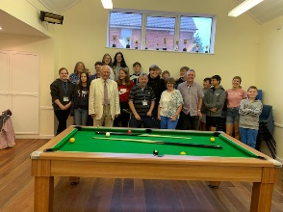
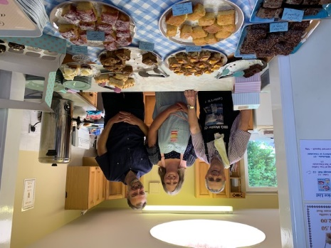
During 2019, the Parish Council organised several events. The first was a coffee morning in the village hall to raise funds for the newly formed youth club.
A full-sized pool table was purchased for the youth club, this stands in the village hall.

The Alderton Swan played host to Meet up Wednesday, the pub supplied tea and coffee and a venue for locals to meet up and chat. This event was well supported for the five months that the pub played host, sadly they changed their opening hours in September and the event moved to the village hall.
In April the Parish Council purchased an outdoor table tennis table, this was placed on the recreation ground and has seen a good level of use.
There were three elections in 2019, these were the local elections, the MEP elections both in May, and a General Election in December. The village hall was the polling station in all cases.
In May, July and September St Andrew’s Church had a Songs of Praise at 3:00pm, sadly only one was well supported and this was the July one when the Roll of Honour from Armistice 100 were presented to each village.
The walking football continues to be well supported, meeting on the recreation ground on the 1st Sunday of every month with an additional meeting on Boxing Day.
On the 6th July the Parish Council arranged the Alderton Show which was held on the recreation ground. There were several stalls and games also the Suffolk Pop Chorus came along to sing and there was a display of vintage cars. This event saw the resurrection of the once popular Alderton and Bawdsey Flower Show. There were several classes ranging from home grown fruit and veg to crafts such as knitting and sewing.
In the evening some local musicians played to the hardy people who stayed out in the rain.
24th August saw the annual cricket and rounders event sponsored by the Alderton Swan and the Sorrell Horse in Shottisham. Alderton were the winners again.
On the 22nd September an end of summer party was arranged on the recreation ground between 2:00 and 9:00 pm.
As a result of Meet-up Wednesday’s a knit and natter group was set up in August to meet in the pub on the first Thursday of the month. This moved to a private home from the 1st November and has around 6 people attending on the 1st Friday of the month. Attendees meet to knit whatever project they are working on and to share a cup of tea and to chat.
St Andrew’s Church report that there were 3 weddings, 5 funerals, 1 memorial service and 1 baptism during 2019. The Parochial church Council met 4 times including the APCM and there are around 20 people on the electoral role. The Reverend Ruth Hatchett announced in September that she would be retiring in early 2020 and a replacement would be advertised for.
The Parish council met 6 times including the AGM and an emergency meeting to “Save Our Swan” as the pub was under threat of closure. Flag of Suffolk who own the pub went on to assure us that the pub would remain open, but the opening hours would be shortened even further. The Parish Council benefits from a full council of 9 members.
The Alderton Swan closed its doors for ever on Wednesday 24th December 2019.

