Annual Report for Alderton
January 1st 2018 to December 31st 2018
During the year, St Andrew’s Church reports that there was 1 wedding, 3 funeral services, 2 burials and 1 memorial service. No baptisms took place. The Parochial Church council met 4 times including the APCM, there are 35 people on the electoral role.
Between 13th October and the 30th November, St Andrew’s hosted an exhibition to commemorate the signing of the armistice that ended WWI. The exhibition told the life stories of the men who died serving their country from the villages surrounding Alderton, known as the Deben Cluster. These are: Alderton, Bawdsey, Boyton, Capel St Andrew, Hollesley, Ramsholt, Shottisham and Sutton.
The team were lucky enough to have a visit from About Anglia TV and the event featured on the evening news on Monday 15th October.
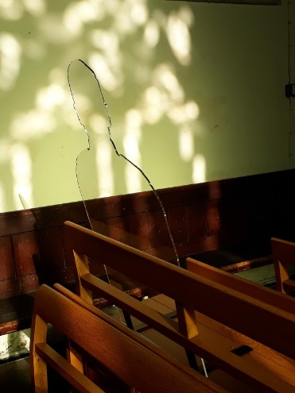
The team were also awarded 8 of the “There but not there “silhouettes from the Armed Forces Covenant. These have now been distributed one to each village except Capel St Andrew, which does not have a church.
In addition to telling the life stories of the men who died whilst serving, the team were also able to confirm just over 100 men from the villages who served and returned from the so called “Great War”.
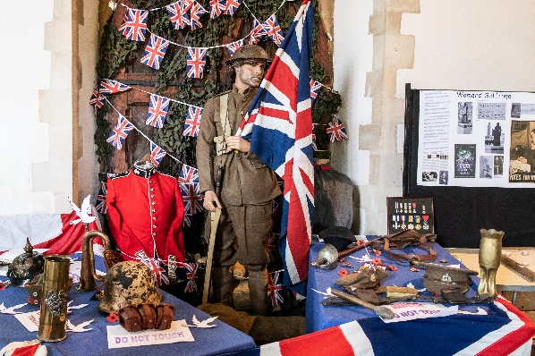
The opening ceremony on 13th October, as well as being filmed was lucky enough to secure the services of two local choirs and a display supplied by Rodney Scott, of weaponry and uniforms.
The team plan to produce some permanent commemorative item for each village, this will be reported on in 2019.
The children from Bawdsey Primary School produced some lovely art work and acrostic poetry.
Finally, several artefacts were loaned by various people, from photographs in frames of family members to trench tools and ammunition belts.

The Parish Council met 8 times and benefits from a full council of 9 members. The council arranged a village fete which was held on the 1st Saturday in July and a pensioners Christmas dinner which took place on Friday 8th December.
The children’s play equipment, located on the recreation ground benefitted from some new equipment to replace that which was condemned as unsafe in 2017, in addition the small pavilion on the recreation ground has been re-decorated both inside and out.
A local man has set up a walking football group, which currently meets about once a month on a Sunday, the other very successful group that meets is the Bowls Club.
In December Just 42 offered the village the chance of a youth club for young people from the age of 11 to 18, this has proved to be very successful.

