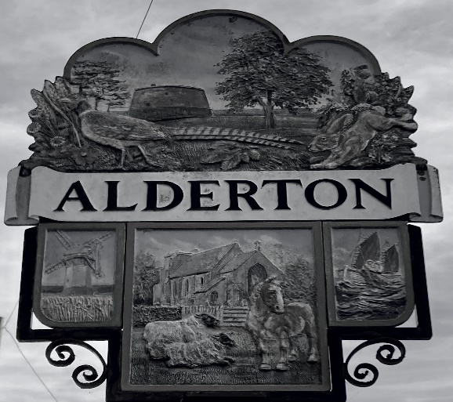

ALDERTON PARISH COUNCIL
PLAY AREA HEALTH & SAFETY

Policy Statement
It is our policy to provide and maintain a safe environment at the Recreation ground in Alderton
.
In accordance with the Health and Safety at Work etc. Act 1974, we also accept our responsibility for the health and safety of other people who may be affected by our activities.

Alderton Parish Council, hereinafter referred to as the Organisation, actively seeks support from all staff and volunteers, whatever their status, in achieving the objectives of this Health and Safety Policy (“the Policy”).

The allocation of duties for safety matters and the arrangements for implementation of the Policy are set out. The Policy will be kept up to date as required. To ensure this, the Policy and the way in which it is operated, will be reviewed annually.

Day-to-day health and safety responsibilities:
- Alderton Parish Council is responsible for all day-to-day health and safety matters relating to the Recreation ground, Alderton (“the premises”).

Monitoring the Health and Safety Policy
- Alderton Parish Council is responsible for checking the Policy to ensure continued effectiveness, particularly that:
  - Health and safety responsibilities are being properly discharged

Health and Safety Budget
- Allocation will be made annually in the budget for the purpose of health and safety, i.e. ROSPA Inspection.

General Safety
A declaration by Alderton Parish Council must be signed when the Policy has been read
and understood.

Accidents
If an accident occurs at the play area it should be reported to Alderton Parish Council, who will record the accident. Should the accident be reportable under the Reporting of Injuries, Diseases and Dangerous Occurrences Regulations 1995 (RIDDOR), this will be done by Alderton Parish Council.

Risk Assessments of the play equipment at the Recreation ground will be carried out annually by ROSPA inspectors.

Health and Safety Inspections
The play area will be inspected on a monthly basis by a member of Alderton Parish Council and recorded on a record sheet.

Policy Review
This Policy will be reviewed and updated following any major changes or annually whichever occurs first.

Signed:
Dated: 4th March 2024
Joy Andrews – Clerk to Alderton Parish Council

