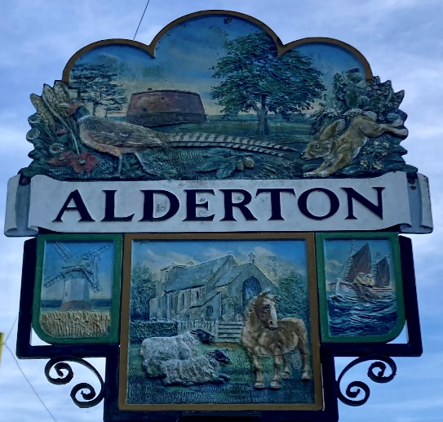

ALDERTON PARISH COUNCIL

CHILD PROTECTION SAFEGUARDING POLICY

Introduction

We believe that children and young people have the right to have fun and be safe in the services provided for them and the activities they choose to participate in.
We believe all children and young people have the right to live their lives to the fullest potential, to be protected, to have the opportunity to participate in and enjoy any activity and to be treated with dignity and respect.
We believe that all children and young people irrespective of their age, class, religion, culture, disability, gender, ethnicity or sexual preference have the right to protection.
The policy affects every elected member, staff member, volunteer and anyone working on behalf of
and/or representing the Council.

This Council is committed to:

- Ensuring that all children and young people are protected and kept safe from harm whilst engaged in services organised and provided by the Council.

- Safeguard the welfare of children and young people who use the Council's services or who attend activities within its venues, by protecting them from abuse
.
This Council recognises its responsibilities under the terms of the Children Act 2004, earlier Children’s Acts and other relevant legislation that the plans for ensuring that its functions are discharged having regard to the need to safeguard and promote the welfare of children and young people.
This policy applies to all situations within the Council’s operation, which could potentially involve children and young people.
Good practice guidelines are provided in this policy to guide staff and nominated representatives in the protection of children and young people and to protect our staff and nominated representatives from allegations of abuse and to reassure parents and guardians.

Definitions:

- The term children or young person is used to refer to anyone under the age of 18 years.
- The term parent is used as a generic term to represent anyone with legal parental responsibility.
- The terms elected members, staff and volunteers is used to

- refer to employees, councillors, volunteers, and anyone working on behalf of and/or representing the Council, including temporary and agency staff and contractors.

Aims of the Policy:

This Council accepts its moral and legal responsibility to implement procedures, provide a duty of care for children and young people, safeguard their well-being and protect them when they are engaged in services organised and provided by the Council or when they come into contact with Council staff, those on work experience, elected members and volunteers.
The Council aims to do this by:
- Raising an awareness throughout the Council and beyond of the statutory “duty of care” relating to children and young people and actively encourage good practice amongst all staff, elected members and volunteers.

- Creating a safe and healthy environment within all its services, avoiding situations where abuse or allegations of abuse may occur.

- Respecting and promoting the rights, wishes and feelings of children and young people. Listening to children and young people, minimising dangers, and working closely with other agencies.

- Recruiting, training, supervising, and supporting staff, elected members and volunteers who work with children and young people to adopt best practice to safeguard and protect themselves against false allegations.

- Staff and volunteers who work with children and young people will be subject to verification by having a ‘Disclosure and Barring Service’ check.

- Responding to any allegations appropriately and implementing the appropriate disciplinary and appeals procedures.

- Requiring staff, elected members and volunteers to adopt and abide by this policy and guidelines.

Use of Contractors:
This Council and its staff, elected members and volunteers should take care that contractors doing work on behalf of the Council will be monitored appropriately. Any contractor or sub-contractor, engaged by the Council in areas where there is a possibility their workers are likely to come into contact with children and young people, should have a similarly robust Child Protection Policy, or failing this, must agree to comply with the terms of this policy. Contractors will be monitored by the Officer responsible for the contract.

Alleged or Suspected Child Abuse:
These procedures will inform staff, all elected members and volunteers of what actions they should take if they have concerns or encounter a case of alleged or suspected child abuse.
In responding to ‘Concerns and Allegations’ It is important that all staff, elected members and volunteers are aware that the first person that has concerns or encounters a case of alleged or suspected abuse is not responsible for deciding whether abuse has occurred.

It is not the place of any Officer of the Council to investigate allegations. However, staff, elected members and volunteers do have a duty of care to the child or young person which means they must report any suspicions they may have. All reports should be treated as confidential and with respect to the person raising the concern regardless of the outcome.
It is the duty of any member, or council employee or volunteer to report any concerns about a child being subject to abuse, receive a disclosure or are aware of Members, or colleagues behaving in an inappropriate manor.
Staff, elected members and volunteers may need to respond the following where there is a concern or a case of alleged or suspected abuse. In the case of an emergency where a child is in danger a ‘999’ phone call should be made immediately.

- Responding to a child or young person disclosing abuse, i.e. they make an allegation of abuse

- Responding to allegations or concerns about a member of staff, elected member or volunteer from your own observation or due to a complaint.

- Responding to allegations or concerns about any other person, i.e. parent, carer, other service user.

- They will record in writing all the details that you are aware of and what was said using the child or young person’s own words, immediately. In your record you should include the following:

a) The date and time
b) The child or young person’s name, address and date of birth
c) The nature of the allegation
d) Their observations – a description of the child or young person’s behaviour, physical and emotional state, and any visible injuries.
e) Exactly what the child or young person said and what you said, recording the child or young person’s account of what has happened as closely as possible.
f) Sign and date what they have recorded.
We will not ask questions, other than the child or young person’s name, address and date of birth. Reassure the child or young person that they have done the right thing in telling us.
We will contact our local Social Services or the Police without delay and follow their guidance.
Every effort will be made to ensure that confidentiality is maintained for all concerned. Information handled and disseminated on a need-to-know basis only. This is usually Social Services or the Police. It is extremely important that allegations or concerns are not discussed, as any breach of confidentiality could be damaging to the child or young person, their family, those who are the subject of allegations and any child protection investigations that may follow.
Informing the parents of a child or young person of concerns we may have will be dealt with by Social Services. Parents will not be informed if they are the subject of the allegation. Any individual against whom an allegation has been made has the right to be notified about the cause for concern but this will be done by Social Services and the Police. It is important that the timing of this does not prejudice the investigation; therefore, confidentiality is of the utmost importance.
Recorded information will be handed over to Social Services or the Police and any copies stored in a secure place with limited access in line with data protection laws (e.g. that information is accurate, regularly updated, relevant and secure). If enquiries arise from the public or any branch of the media, it is vital that all our staff, elected members and volunteers are fully briefed to not make any comments regarding the situation.

Photography:

Consent must be sought from parents when cameras and other image recorders are used to picture children and young people.
Staff, elected members and volunteers should always be vigilant regarding people using cameras or videos within Council services and at any events or activities which involve children and young people.
Parents must be informed that photographs of their child or young person may be taken during Council services, activities or events, and signed parental consent needs to be obtained agreeing to this. This must include information about how and where these photographs will be used.
The following guidelines

- Do not allow unsupervised access to children or young people or one to one photographic session.

- The child or young person should be happy with having their picture taken

- The names of children or young people should not be used in photographs or video footage, unless with the express permission of the child or young person’s parent.

Sources of Information / Support:

ChildLine
Free helpline for children and young people
in the UK. children and young people can
call to talk about any problem
www.childline.org.uk
T: 0800 1111

NSPCC
Information for children and adults
www.nspcc.org.uk/html/home/needadvice/ne
edadvice.htm
T: 0808 800 5000

Samaritans
www.samaritans.org
T: 08457 909090

Domestic Violence
T: 08457 909090

Signed by: Name:

Position:

Date:

Reviewed November 2024

